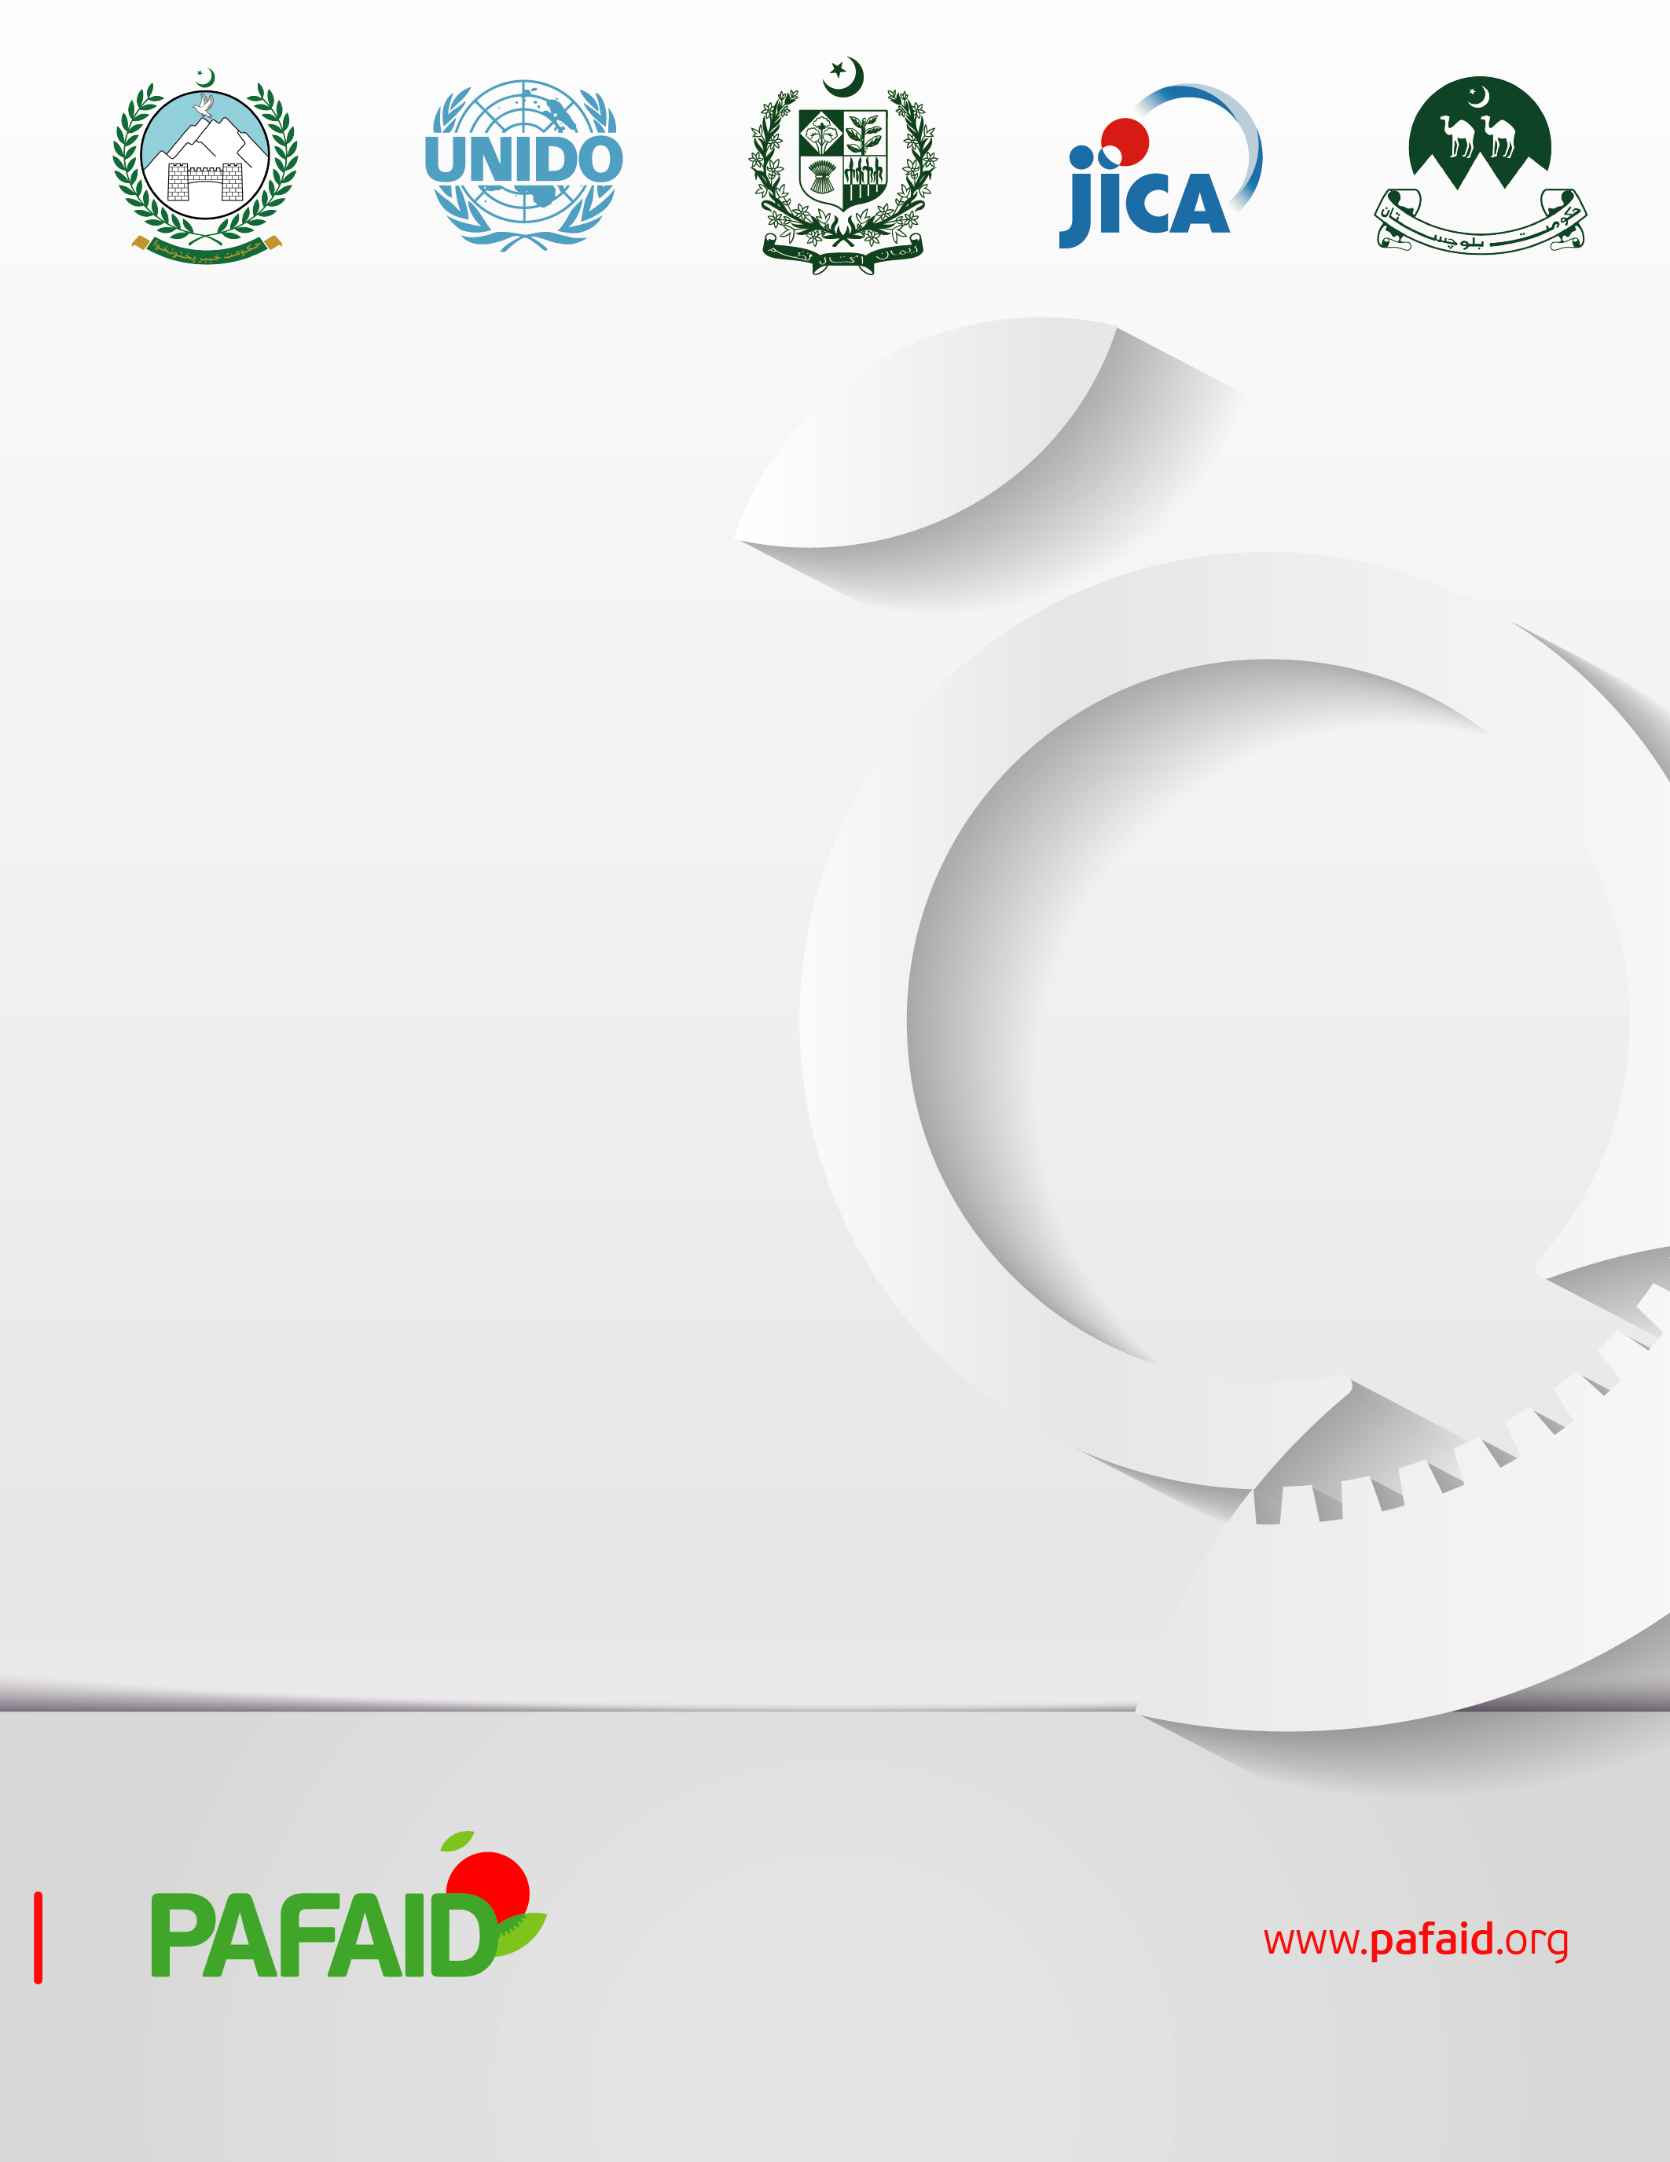
Balochistan Star pack Packaging Competition

Project Background:
United Nations industrial development Organization (UNIDO) is a specialized agency of the United Nations that assists countries in economic and industrial development.
The Project for Agri-Food and Agro-Industry Development Assistance (PAFAID) is funded by the Government of Japan through the Japan International Cooperation Agency (JICA) and implemented by the United Nations Industrial Development Organization (UNIDO). UNIDO provides technical support to improve the quality and safety, value addition, and productivity of the apple value chain in Balochistan, which in turn can contribute to better marketability, higher profit, and access to high-end markets. This project aims to rejuvenate the livelihood of apple value chain actors through the introduction of best practices in terms of compliance and value addition, working with the apple value chain stakeholders in selected districts of Balochistan, including Quetta, Killa Abdullah, Pishin, Killa Saifullah, Mastung and Kalat. Moreover, the project will provide technical support to the relevant governmental bodies to increase their capacity, and will foster collaboration with the industry on best practices for value addition, and compliance, and ultimately promote improved livelihoods of participants along the value chain, including manufacturers and processors.
The uplifting of the apple value chain in upland Balochistan plays a primary role in raising rural incomes and creating jobs while decreasing the pre- and post-harvest losses through the introduction and promotion of value-adding, food safety, and quality compliance practices across the apple value chain.
The project is expected to create a total of 5,000 new jobs for the agri-food industry and will improve the livelihood of 50,000 beneficiaries through project activities for rural farmers/workers. The project will contribute to Sustainable Development Goals (SDGs) 1, 2, 5, 9, 12, and 17.

Apple startPack Balochistan:
Under its PAFAID project, UNIDO is introducing Pakistan’s first student packaging contest in collaboration with Balochistan Food Authority (https://bfa.gob.pk/) and World Packaging Organization (https://www.worldpackaging.org/) and partnership with its partner institutions. The contest calls upon the youth of Balochistan to unleash their creative, technical, marketing, and entrepreneurial skills for designing modern and efficient Apple packaging Solutions.
Partner Institutions:
Following Balochustan’s leading Institutions are participating in the competition,
- University of Balochistan (UOB)
- Agriculture College Quetta
- Sardar Bahadur Khan Women University (SBK)
- BUITEMS
Location:
The competition will be held at BUITEMS main campus as per following dates:
Applications form submissions: 13 July 2022- 15 Oct 2022
Evaluation of Concept note and Presentation: 16 Oct- 26 Oct 2022
Exhibition: first or 2nd week of November 2022
Categories of Competition:
- Suggesting new or improved visual design/artwork of an existing package. In this category, the student has to improve the branding identity of the product.
- Suggesting new structural packaging design (new mold) the student can even suggest changing the existing packaging material by proposing a new sustainable material.
- This category involves offering new smart or intelligent packaging, to improve the supply of food to a growing global population and prevent its waste, and if possible the extension of the shelf life of apples.
Judging Criteria:
The student’s project will be judged based on the following criteria.
- Functionality
- Sustainability
- Packaging design
- Labeling information
- Execution
- Innovation and creativity
Impact of the activity:
As with all methodologies used in competition helps students to gain technical skills and knowledge. It may improve the productivity of students’ inputs to make and suggest greater choices and contribute to the social and economic development of Balochistan.

